Twitter4j.properties before shot

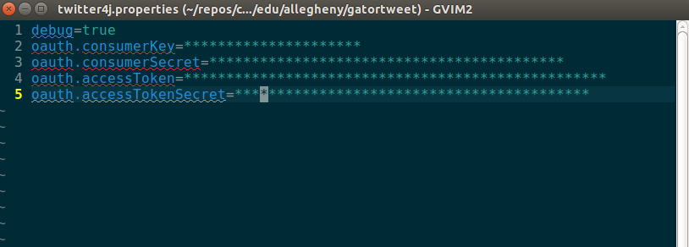

After compiling CreateProperties:

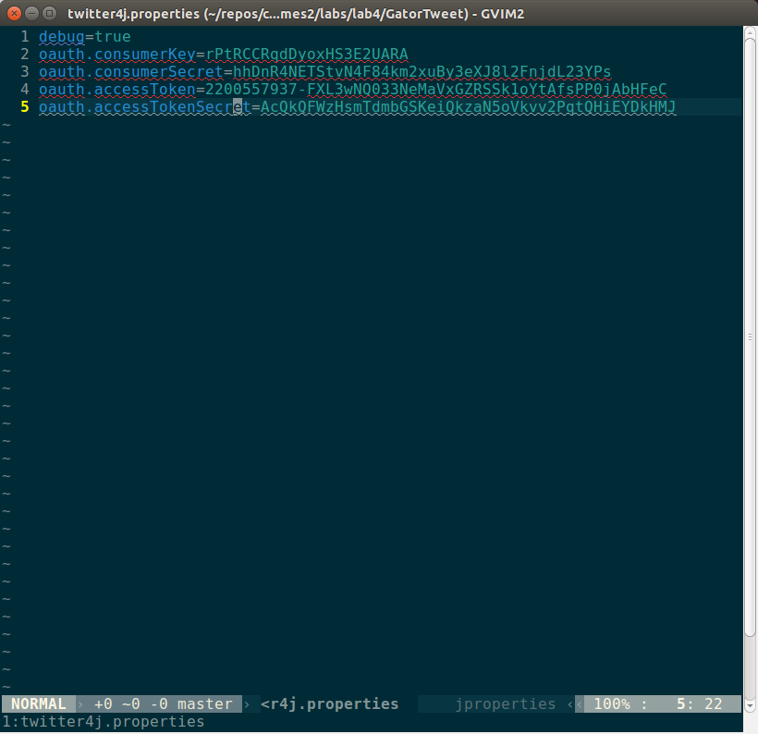

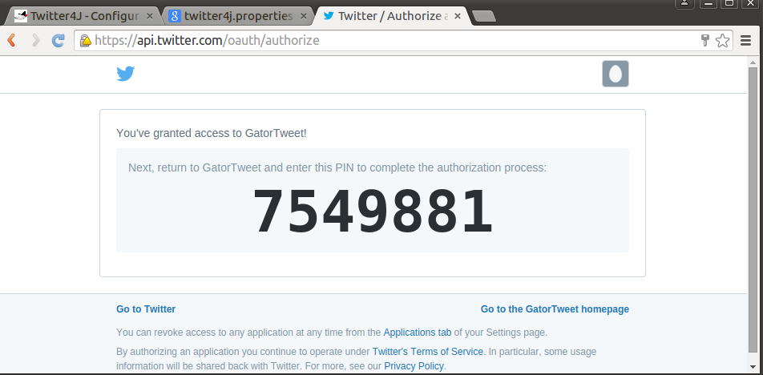

Attempted run of the GetHomeTimeline program
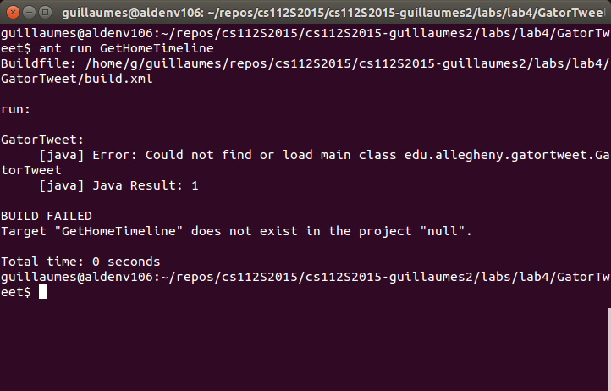

When GetHomeTimeline when debugging mode is enabled
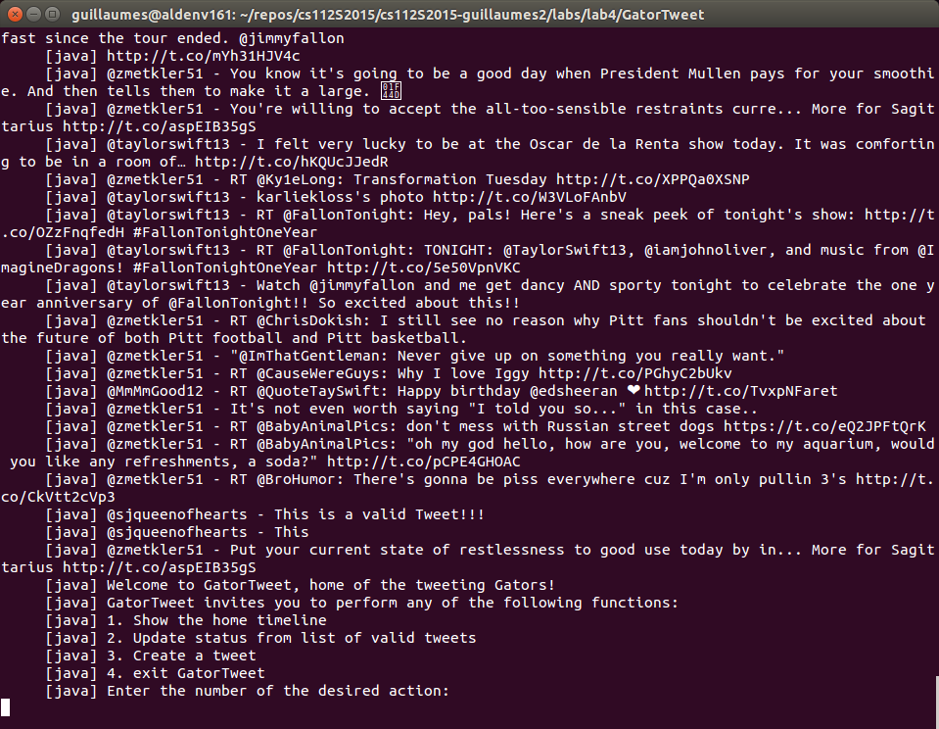

Output for running 1 (Gets Home Timeline):

[java] Showing @sjqueenofhearts's home timeline.
[java] @nytimes - 8 trips inspired by Oscar-nominated films http://t.co/65rJGGiX13 http://t.co/gBTmgVKiZP
[java] @nytimes - At Chipotle, how many calories do people really eat? http://t.co/74Yw5sCx0M http://t.co/zVHk650Zwv
[java] @nytimes - A New Year With a Name That’s a Matter of Opinion http://t.co/L6cHvtEQU2
[java] @nfl - Mock Draft 2.0 (via @MoveTheSticks):
[java]
[java] 1. J. Winston
[java] 2. D. Fowler
[java] 3. L. Williams
[java] 4-32. http://t.co/fpm8EXzJ8W http://t.co/J9TdjXKrT4
[java] @nytimes - He left his friends, family and a life of guilty pleasures in Egypt to join ISIS http://t.co/N76zhu1eyg http://t.co/5Lx7yGvmmI
[java] @selenagomez - The reason I love my job.. http://t.co/38O1yMj8UQ
[java] @nytimes - White House Struggles on Immigration Ruling http://t.co/V2gRLl24uQ
[java] @espn - RT @SportsCenter: Why We Love Sports Today: Duke and UNC honor legendary coach Dean Smith together with pregame moment of silence. http://t…
[java] @nytimes - Larry David says the hardest part about acting on Broadway is waiting to talk http://t.co/or9HAJLLIS http://t.co/wOre0LtUgx
[java] @taylorswift13 - RT @GiGiHadid: ✈️ Ohhh HIII my loves @karliekloss @taylorswift13 @voguemagazine http://t.co/h5W1iHT3Gg
[java] @nytimes - RT @abbygoodnough: Did you get health insurance through an Affordable Care Act marketplace? Tell The New York Times about it here: http://t…
[java] @nfl - Cut through the hype.
[java] Skip the hyperbole.
[java]
[java] These are the 12 players to watch at #NFLCombine: http://t.co/iOWC4UwJqE http://t.co/2CHCRBPU1Y
[java] @nytimes - RT @UpshotNYT: Readers wanted to know about our Chipotle analysis. We're here to serve: http://t.co/Z3BwcHyTnI
[java] @nytimes - How an identical brainstorming exercise produced very different results in two distinct cultural contexts http://t.co/BB0TNUEirX
[java] @nytimes - Illinois Governor Proposes $6 Billion in Cuts and Reducing Pension Benefits http://t.co/qsw9MVSVWq
[java] @nytimes - 36 hours in Beijing http://t.co/wU0fRrrnAl http://t.co/l6EHqMA0vm
[java] @nfl - Rex Ryan really, really, REALLY enjoyed watching @Patriots win #SB49: http://t.co/hpCkPNTsdX
[java]
[java] (SPOILERS: He hated it) http://t.co/6oQMTkjjiq
[java] @nytimes - RT @NYTFashion: Jeremy Scott knows how to draw a crowd — and create a scene. http://t.co/QAfNeheC64 http://t.co/9AkT9tmL4E
[java] @nytimes - Updated: Maps that explain the crisis in Ukraine http://t.co/ancySdsgCZ http://t.co/cSoXe23wOk
[java] @espn - Colin Kaepernick WENT OFF on a fan on Twitter who called out the San Francisco 49ers​ quarterback minutes earlier: http://t.co/qnkas5pVIO

Output from running 2 (post valid statuses from Array):

(Note: This is the last Tweet posted as an example of the source code that was returned for each tweet posted.)

[java] [Wed Feb 18 22:19:06 EST 2015]Request:
[java] [Wed Feb 18 22:19:06 EST 2015]POST https://api.twitter.com/1.1/statuses/update.json
[java] [Wed Feb 18 22:19:06 EST 2015]OAuth base string: POST&https%3A%2F%2Fapi.twitter.com%2F1.1%2Fstatuses%2Fupdate.json&include_entities%3D1%26include_rts%3D1%26oauth_consumer_key%3DrPtRCCRqdDyoxHS3E2UARA%26oauth_nonce%3D2982950368%26oauth_signature_method%3DHMAC-SHA1%26oauth_timestamp%3D1424315946%26oauth_token%3D2200557937-FXL3wNQ033NeMaVxGZRSSk1oYtAfsPP0jAbHFeC%26oauth_version%3D1.0%26status%3DShould%2520I%2520work%2520on%2520my%2520lego%2520robot%2520now%253F%2520
[java] [Wed Feb 18 22:19:06 EST 2015]OAuth signature: BQhP2m1C4a7ZnsBk0LcUb2eD7lI=
[java] [Wed Feb 18 22:19:06 EST 2015]Authorization: ********************************************************************************************************************************************************************************************************************************************************************************
[java] [Wed Feb 18 22:19:06 EST 2015]X-Twitter-Client-Version: 3.0.5
[java] [Wed Feb 18 22:19:06 EST 2015]X-Twitter-Client-URL: http://twitter4j.org/en/twitter4j-3.0.5.xml
[java] [Wed Feb 18 22:19:06 EST 2015]X-Twitter-Client: Twitter4J
[java] [Wed Feb 18 22:19:06 EST 2015]User-Agent: twitter4j http://twitter4j.org/ /3.0.5
[java] [Wed Feb 18 22:19:06 EST 2015]Accept-Encoding: gzip
[java] [Wed Feb 18 22:19:06 EST 2015]Post Params: status=Should%20I%20work%20on%20my%20lego%20robot%20now%3F%20&include_entities=1&include_rts=1
[java] [Wed Feb 18 22:19:06 EST 2015]Response:
[java] [Wed Feb 18 22:19:06 EST 2015]date: Thu, 19 Feb 2015 03:19:06 UTC
[java] [Wed Feb 18 22:19:06 EST 2015]HTTP/1.1 200 OK
[java] [Wed Feb 18 22:19:06 EST 2015]server: tsa_b
[java] [Wed Feb 18 22:19:06 EST 2015]content-length: 780
[java] [Wed Feb 18 22:19:06 EST 2015]expires: Tue, 31 Mar 1981 05:00:00 GMT
[java] [Wed Feb 18 22:19:06 EST 2015]x-response-time: 65
[java] [Wed Feb 18 22:19:06 EST 2015]x-frame-options: SAMEORIGIN
[java] [Wed Feb 18 22:19:06 EST 2015]content-encoding: gzip
[java] [Wed Feb 18 22:19:06 EST 2015]x-transaction: b2ea2fefc587f09b
[java] [Wed Feb 18 22:19:06 EST 2015]strict-transport-security: max-age=631138519
[java] [Wed Feb 18 22:19:06 EST 2015]pragma: no-cache
[java] [Wed Feb 18 22:19:06 EST 2015]set-cookie: guest_id=v1%3A142431594661041575; Domain=.twitter.com; Path=/; Expires=Sat, 18-Feb-2017 03:19:06 UTC
[java] [Wed Feb 18 22:19:06 EST 2015]set-cookie: lang=en
[java] [Wed Feb 18 22:19:06 EST 2015]last-modified: Thu, 19 Feb 2015 03:19:06 GMT
[java] [Wed Feb 18 22:19:06 EST 2015]x-xss-protection: 1; mode=block
[java] [Wed Feb 18 22:19:06 EST 2015]x-content-type-options: nosniff
[java] [Wed Feb 18 22:19:06 EST 2015]content-disposition: attachment; filename=json.json
[java] [Wed Feb 18 22:19:06 EST 2015]x-connection-hash: 764a4b280819e1578a0a6891ca304d8d
[java] [Wed Feb 18 22:19:06 EST 2015]x-access-level: read-write-directmessages
[java] [Wed Feb 18 22:19:06 EST 2015]x-twitter-response-tags: BouncerCompliant
[java] [Wed Feb 18 22:19:06 EST 2015]content-type: application/json;charset=utf-8
[java] [Wed Feb 18 22:19:06 EST 2015]cache-control: no-cache, no-store, must-revalidate, pre-check=0, post-check=0
[java] [Wed Feb 18 22:19:06 EST 2015]status: 200 OK
[java] [Wed Feb 18 22:19:06 EST 2015]{"in_reply_to_status_id_str":null,"in_reply_to_status_id":null,"coordinates":null,"created_at":"Thu Feb 19 03:19:06 +0000 2015","truncated":false,"in_reply_to_user_id_str":null,"source":"<a href=\"http://www.cs.allegheny.edu/sites/cs112S2013\" rel=\"nofollow\">GatorTweet<\/a>","retweet_count":0,"retweeted":false,"geo":null,"in_reply_to_screen_name":null,"entities":{"urls":[],"hashtags":[],"user_mentions":[],"symbols":[]},"id_str":"568248382646575104","in_reply_to_user_id":null,"favorite_count":0,"id":568248382646575104,"text":"Should I work on my lego robot now?","place":null,"contributors":null,"lang":"en","user":{"utc_offset":null,"friends_count":13,"profile_image_url_https":"https://abs.twimg.com/sticky/default_profile_images/default_profile_4_normal.png","listed_count":0,"profile_background_image_url":"http://abs.twimg.com/images/themes/theme1/bg.png","default_profile_image":true,"favourites_count":2,"description":"","created_at":"Mon Nov 18 03:01:19 +0000 2013","is_translator":false,"profile_background_image_url_https":"https://abs.twimg.com/images/themes/theme1/bg.png","protected":false,"screen_name":"sjqueenofhearts","id_str":"2200557937","profile_link_color":"0084B4","is_translation_enabled":false,"id":2200557937,"geo_enabled":false,"profile_background_color":"C0DEED","lang":"en","profile_sidebar_border_color":"C0DEED","profile_location":null,"profile_text_color":"333333","verified":false,"profile_image_url":"http://abs.twimg.com/sticky/default_profile_images/default_profile_4_normal.png","time_zone":null,"url":null,"contributors_enabled":false,"profile_background_tile":false,"entities":{"description":{"urls":[]}},"statuses_count":15,"follow_request_sent":false,"followers_count":3,"profile_use_background_image":true,"default_profile":true,"following":false,"name":"SJ","location":"","profile_sidebar_fill_color":"DDEEF6","notifications":false},"favorited":false}
[java] Successfully updated the statuses to [Should I work on my lego robot now?].

Example from running 3 (Post a tweet from terminal):

[java] Welcome to GatorTweet, home of the tweeting Gators!
[java] GatorTweet invites you to perform any of the following functions:
[java] 1. Show the home timeline
[java] 2. Update status from list of valid tweets
[java] 3. Create a tweet
[java] 4. exit GatorTweet
[java] Enter the number of the desired action:
3
[java] Please enter a 140 character tweet to be posted now:
I am so excited to start Lab 6 tomorrow!!!! #CS4Life
[java] [Wed Feb 18 22:24:37 EST 2015]Request:
[java] [Wed Feb 18 22:24:37 EST 2015]POST https://api.twitter.com/1.1/statuses/update.json
[java] [Wed Feb 18 22:24:37 EST 2015]OAuth base string: POST&https%3A%2F%2Fapi.twitter.com%2F1.1%2Fstatuses%2Fupdate.json&include_entities%3D1%26include_rts%3D1%26oauth_consumer_key%3DrPtRCCRqdDyoxHS3E2UARA%26oauth_nonce%3D833656998%26oauth_signature_method%3DHMAC-SHA1%26oauth_timestamp%3D1424316277%26oauth_token%3D2200557937-FXL3wNQ033NeMaVxGZRSSk1oYtAfsPP0jAbHFeC%26oauth_version%3D1.0%26status%3DI%2520am%2520so%2520excited%2520to%2520start%2520Lab%25206%2520tomorrow%2521%2521%2521%2521%2520%2523CS4Life
[java] [Wed Feb 18 22:24:37 EST 2015]OAuth signature: jxq4Pc8CTRgInir34fxdz6Bn994=
[java] [Wed Feb 18 22:24:37 EST 2015]Authorization: *******************************************************************************************************************************************************************************************************************************************************************************
[java] [Wed Feb 18 22:24:37 EST 2015]X-Twitter-Client-Version: 3.0.5
[java] [Wed Feb 18 22:24:37 EST 2015]X-Twitter-Client-URL: http://twitter4j.org/en/twitter4j-3.0.5.xml
[java] [Wed Feb 18 22:24:37 EST 2015]X-Twitter-Client: Twitter4J
[java] [Wed Feb 18 22:24:37 EST 2015]User-Agent: twitter4j http://twitter4j.org/ /3.0.5
[java] [Wed Feb 18 22:24:37 EST 2015]Accept-Encoding: gzip
[java] [Wed Feb 18 22:24:37 EST 2015]Post Params: status=I%20am%20so%20excited%20to%20start%20Lab%206%20tomorrow%21%21%21%21%20%23CS4Life&include_entities=1&include_rts=1
[java] [Wed Feb 18 22:24:37 EST 2015]Response:
[java] [Wed Feb 18 22:24:37 EST 2015]date: Thu, 19 Feb 2015 03:24:37 UTC
[java] [Wed Feb 18 22:24:37 EST 2015]HTTP/1.1 200 OK
[java] [Wed Feb 18 22:24:37 EST 2015]server: tsa_b
[java] [Wed Feb 18 22:24:37 EST 2015]content-length: 813
[java] [Wed Feb 18 22:24:37 EST 2015]expires: Tue, 31 Mar 1981 05:00:00 GMT
[java] [Wed Feb 18 22:24:37 EST 2015]x-response-time: 60
[java] [Wed Feb 18 22:24:37 EST 2015]x-frame-options: SAMEORIGIN
[java] [Wed Feb 18 22:24:37 EST 2015]content-encoding: gzip
[java] [Wed Feb 18 22:24:37 EST 2015]x-transaction: 80395328dab7f5b1
[java] [Wed Feb 18 22:24:37 EST 2015]strict-transport-security: max-age=631138519
[java] [Wed Feb 18 22:24:37 EST 2015]pragma: no-cache
[java] [Wed Feb 18 22:24:37 EST 2015]set-cookie: guest_id=v1%3A142431627787776678; Domain=.twitter.com; Path=/; Expires=Sat, 18-Feb-2017 03:24:37 UTC
[java] [Wed Feb 18 22:24:37 EST 2015]set-cookie: lang=en
[java] [Wed Feb 18 22:24:37 EST 2015]last-modified: Thu, 19 Feb 2015 03:24:37 GMT
[java] [Wed Feb 18 22:24:37 EST 2015]x-xss-protection: 1; mode=block
[java] [Wed Feb 18 22:24:37 EST 2015]x-content-type-options: nosniff
[java] [Wed Feb 18 22:24:37 EST 2015]content-disposition: attachment; filename=json.json
[java] [Wed Feb 18 22:24:37 EST 2015]x-connection-hash: 465e21df98c2ea3a83f2f4d34adef308
[java] [Wed Feb 18 22:24:37 EST 2015]x-access-level: read-write-directmessages
[java] [Wed Feb 18 22:24:37 EST 2015]x-twitter-response-tags: BouncerCompliant
[java] [Wed Feb 18 22:24:37 EST 2015]content-type: application/json;charset=utf-8
[java] [Wed Feb 18 22:24:37 EST 2015]cache-control: no-cache, no-store, must-revalidate, pre-check=0, post-check=0
[java] [Wed Feb 18 22:24:37 EST 2015]status: 200 OK
[java] [Wed Feb 18 22:24:37 EST 2015]{"in_reply_to_status_id_str":null,"in_reply_to_status_id":null,"coordinates":null,"created_at":"Thu Feb 19 03:24:37 +0000 2015","truncated":false,"in_reply_to_user_id_str":null,"source":"<a href=\"http://www.cs.allegheny.edu/sites/cs112S2013\" rel=\"nofollow\">GatorTweet<\/a>","retweet_count":0,"retweeted":false,"geo":null,"in_reply_to_screen_name":null,"entities":{"urls":[],"hashtags":[{"indices":[44,52],"text":"CS4Life"}],"user_mentions":[],"symbols":[]},"id_str":"568249772093669377","in_reply_to_user_id":null,"favorite_count":0,"id":568249772093669377,"text":"I am so excited to start Lab 6 tomorrow!!!! #CS4Life","place":null,"contributors":null,"lang":"en","user":{"utc_offset":null,"friends_count":13,"profile_image_url_https":"https://abs.twimg.com/sticky/default_profile_images/default_profile_4_normal.png","listed_count":0,"profile_background_image_url":"http://abs.twimg.com/images/themes/theme1/bg.png","default_profile_image":true,"favourites_count":2,"description":"","created_at":"Mon Nov 18 03:01:19 +0000 2013","is_translator":false,"profile_background_image_url_https":"https://abs.twimg.com/images/themes/theme1/bg.png","protected":false,"screen_name":"sjqueenofhearts","id_str":"2200557937","profile_link_color":"0084B4","is_translation_enabled":false,"id":2200557937,"geo_enabled":false,"profile_background_color":"C0DEED","lang":"en","profile_sidebar_border_color":"C0DEED","profile_location":null,"profile_text_color":"333333","verified":false,"profile_image_url":"http://abs.twimg.com/sticky/default_profile_images/default_profile_4_normal.png","time_zone":null,"url":null,"contributors_enabled":false,"profile_background_tile":false,"entities":{"description":{"urls":[]}},"statuses_count":16,"follow_request_sent":false,"followers_count":3,"profile_use_background_image":true,"default_profile":true,"following":false,"name":"SJ","location":"","profile_sidebar_fill_color":"DDEEF6","notifications":false},"favorited":false}

[java] You just successfully updated your status to [I am so excited to start Lab 6 tomorrow!!!! #CS4Life].

